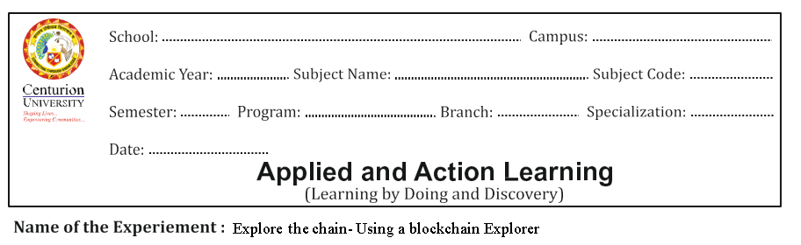
Coding Phase: Pseudo Code / Flow Chart / Algorithm:

ALGORITHM:
- Open blockchain explorer for Bitcoin
- Locate search bar on the explorer.
- Enter transaction hash (TXID) and view details.
- Note transaction info – sender, receiver, amount, fee, block number, status.
- Enter wallet address and view its balance and transaction history.
- Click block number to explore block details – hash, miner, transactions, timestamp.
- Open smart contract address to view code and functions.

* Softwares used
1.Brave Web Browser 2.Blockchain Explorer Website

Applied and Action Learning

* Implementation Phase: Final Output (no error)
First open the bitcoin explorer- https://www.blockchain.com/explorer
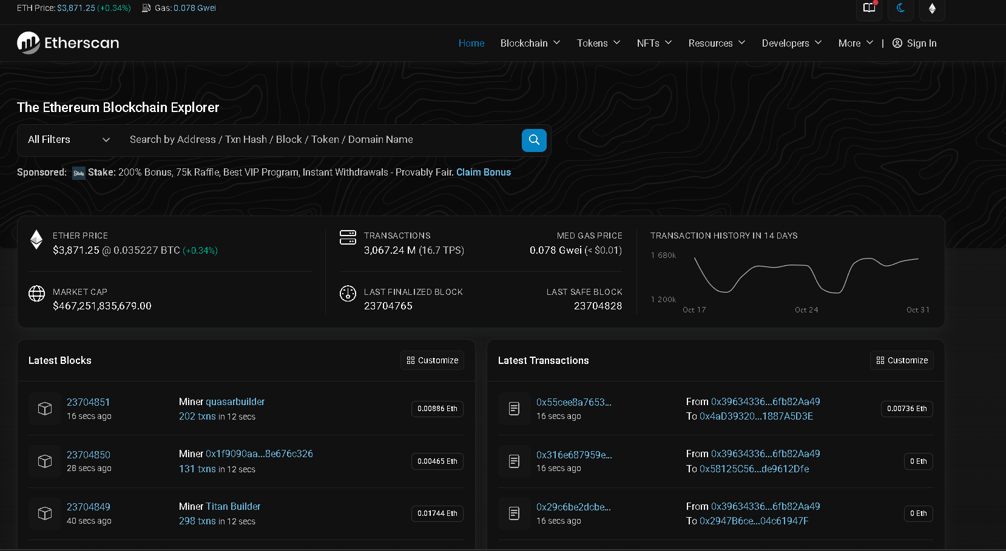


Then is search bar you can search with address,TXID and Token name
After searching will able to see the all details about the transaction like hash,timestamp,status,block number,value ,gas price etc.
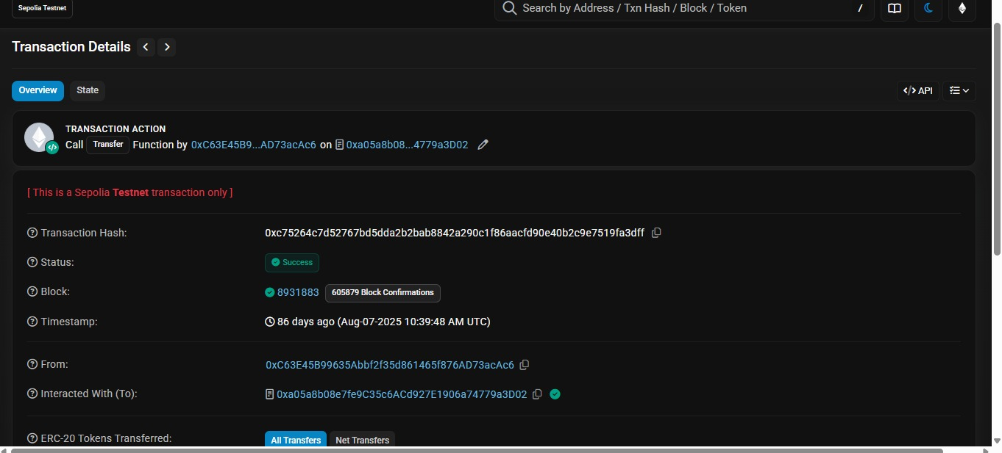

* Implementation Phase: Final Output (no error)
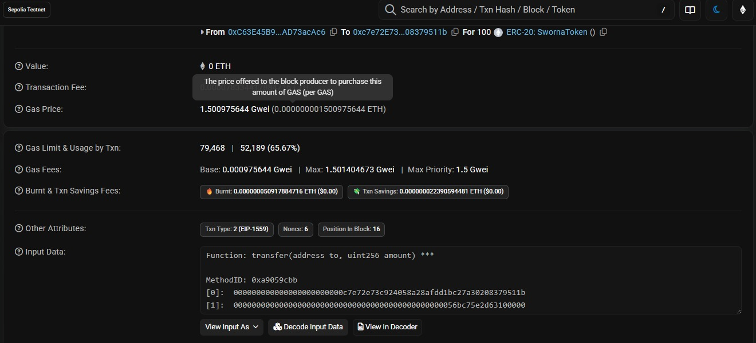
Applied and Action Learning

Now you can see all the details of the transactions on a blockchain explorer

Observations:
- The transaction was successfully found on the Bitcoin blockchain using the provided TXID, showing full de tails such as sender/receiver addresses, amount transferred, and transaction fee.
- The explorer displayed confirmation status, block number, and timestamp, confirming the transaction’s inclusion in the blockchain.
- Inputs and outputs were clearly listed, showing how Bitcoin was spent from one address and sent to one or more recipients.

